**Assignment - 11 A Job Ready Bootcamp in C++, DSA and IOT**

**More on functions in C Language**

**1. Write a function to calculate LCM of two numbers. (TSRS**)

#include<stdio.h>

int findlcm(int,int);

int main()

{

int x,y;

printf("Enter two numbers ");

scanf("%d%d",&x,&y);

printf("LCM is %d",findlcm(x,y));

return 0;

}

int findlcm(int a,int b)

{

int i;

for(i=1;i<=(a*b);i++)

{

if( (i%a==0) && (i%b==0) )

break;

}

return i;

}

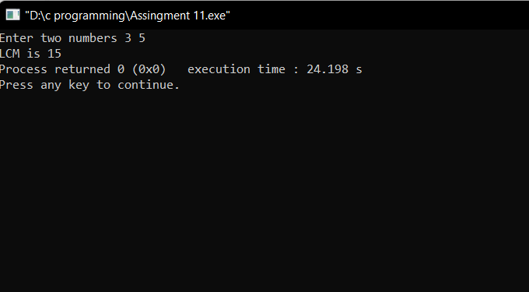

**2. Write a function to calculate HCF of two numbers. (TSRS)**

#include<stdio.h>

int findhcf(int,int);

int main()

{

int x,y;

printf("Enter two numbers ");

scanf("%d%d",&x,&y);

printf("HCF is %d",findhcf(x,y));

return 0;

}

int findhcf(int a,int b)

{

int i,min=1,hcf=1;

min=a<b?a:b;

for(i=1;i<=min;i++)

{

if( (a%i==0) && (b%i==0) )

hcf=i;

}

return hcf;

}

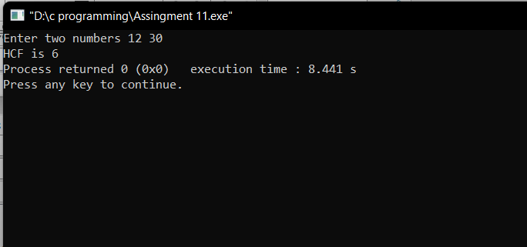

**3. Write a function to check whether a given number is Prime or not. (TSRS)**

#include<stdio.h>

int checkprime(int);

int main()

{

int x;

printf("Enter a numbers ");

scanf("%d",&x);

if (checkprime(x)==2)

printf("not prime");

else

printf("prime");

return 0;

}

int checkprime(int num)

{

int i,count=1;

for(i=2;i<num;i++)

{

if(num%i==0)

count++;

break;

}

return count;

}

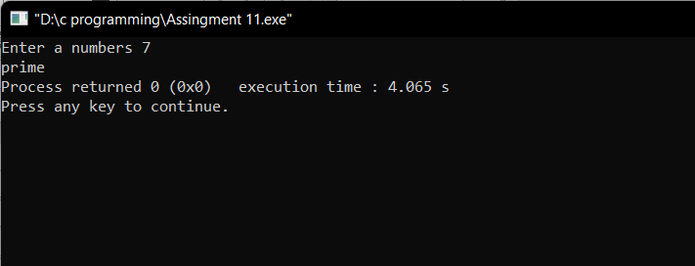

**4. Write a function to find the next prime number of a given number. (TSRS)**

#include<stdio.h>

int nextprime(int);

int main()

{

int x;

printf("Enter a numbers ");

scanf("%d",&x);

printf("%d",nextprime(x));

return 0;

}

int nextprime(int num)

{

int j,k,count=0;

k=num+1;

for(k;1;k++)

{

for(j=1;j<=k;j++)

{

if(k%j==0)

count++;

}

if(count==2)

{

break;

}

count=0;

}

return k;

}

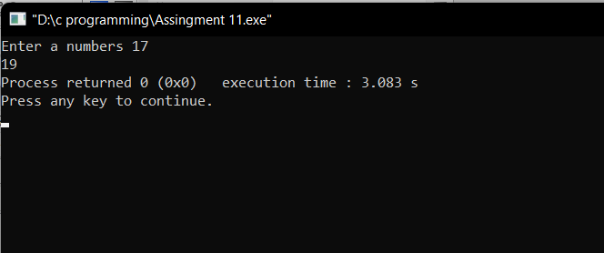

**5. Write a function to print first N prime numbers (TSRN)**

#include<stdio.h>

void printNprime(int);

int main()

{

int x;

printf("Enter a numbers ");

scanf("%d",&x);

printNprime(x);

return 0;

}

void printNprime(int num)

{

int j,i=2,count=0,c;

for(c=1;c<=num;i++)

{

for(j=1;j<=i;j++)

{

if(i%j==0)

count++;

}

if(count==2)

{

printf("%d ",i );

c++;

}

count=0;

}

}

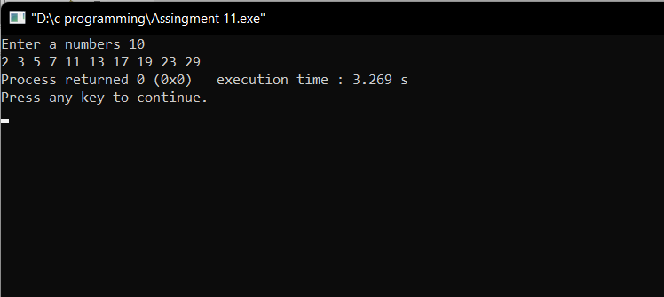

**6. Write a function to print all Prime numbers between two given numbers. (TSRN**)

#include<stdio.h>

void primeBtwoNums(int,int);

int main()

{

int x,y;

printf("Enter two numbers ");

scanf("%d%d",&x,&y);

primeBtwoNums(x,y);

return 0;

}

void primeBtwoNums(int num,int num2)

{

int j,count=0;

num=num+1;

for(num;num<num2;num++)

{

for(j=1;j<=num;j++)

{

if(num%j==0)

count++;

}

if(count==2)

{

printf("%d ",num );

}

count=0;

}

}

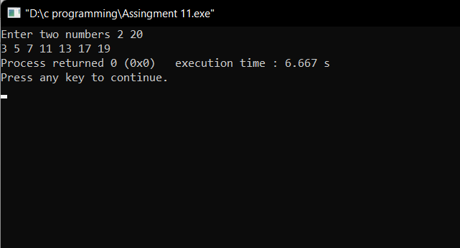

**7. Write a function to print first N terms of Fibonacci series (TSRN)**

#include<stdio.h>

void fibseries(int);

int main()

{

int x;

printf("Enter a numbers ");

scanf("%d",&x);

fibseries(x);

return 0;

}

void fibseries(int num)

{

int i,previous=0,current=1,result=0;

for(i=0;i<=num;i++)

{

result=(previous+current);

printf("%d ",result);

previous=current;

current=result;

}

}

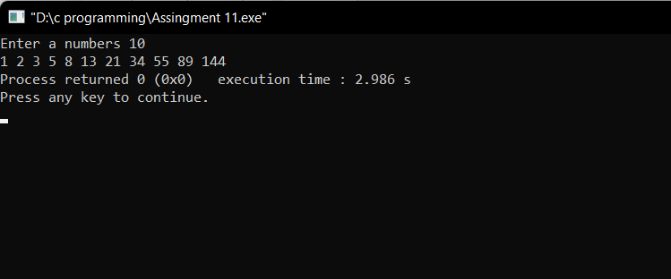

**8. Write a function to print PASCAL Triangle. (TSRN)**

#include<stdio.h>

int fact(int);

int comb(int,int);

void pascal(int);

int perm(int,int);

int main()

{

pascal(5);

return 0;

}

int fact(int n)

{

int i,fact=1;

for(i=1;i<=n;i++)

fact=fact*i;

return fact;

}

int comb(int n,int r)

{

return fact(n)/(fact(r)*fact(n-r));

}

int perm(int n,int r)

{

return fact(n)/(fact(n-r));

}

void pascal(int n)

{

int i,j;

for(i=0;i<=n;i++)

{

for(j=0;j<=(8-i-2);j++)

printf(" ");

for(j=0;j<=i;j++)

{

printf("%d ",comb(i,j));

}

printf("\n");

}

}

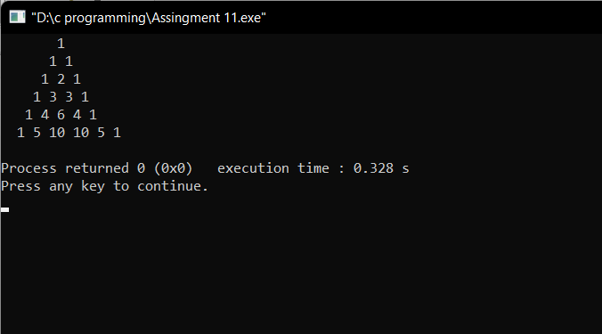

**9. Write a program in C to find the square of any number using the function.**

#include<stdio.h>

int squareofnum(int);

int main()

{

int x;

printf("Enter a numbers ");

scanf("%d",&x);

printf("Square of %d is %d",x,squareofnum(x));

return 0;

}

int squareofnum(int num)

{

int sqr;

sqr=(num*num);

return sqr;

}

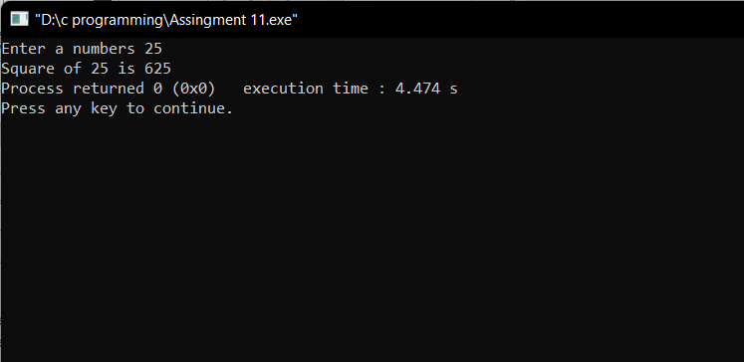

**10. Write a program in C to find the sum of the series 1! /1+2!/2+3!/3+4!/4+5!/5 using the function**.

#include<stdio.h>

int fact(int);

int main()

{

int j,sum=0;

for(j=1;j<=5;j++)

{

sum=sum+( (fact(j) )/ j);

}

printf("%d",sum);

return 0;

}

int fact(int num)

{

int fact=1,i;

for(i=1;i<=num;i++)

{

fact=fact*i;

}

return fact;

}

